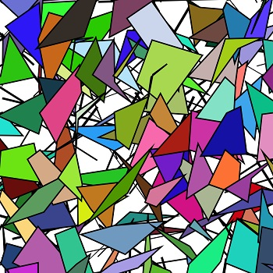

Maret Baer – T1_Avatar and Dress_V2

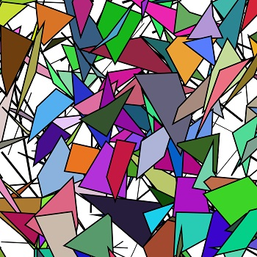

Maret Baer - T4_Avatar V-shape and Dress

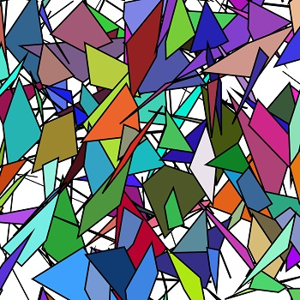

Maret Baer - T5_Ensemble

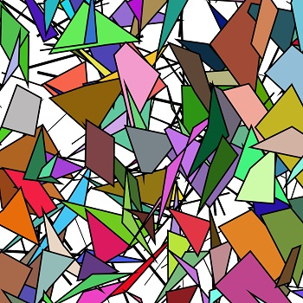

Maret Baer - T6_Garment_Jacket